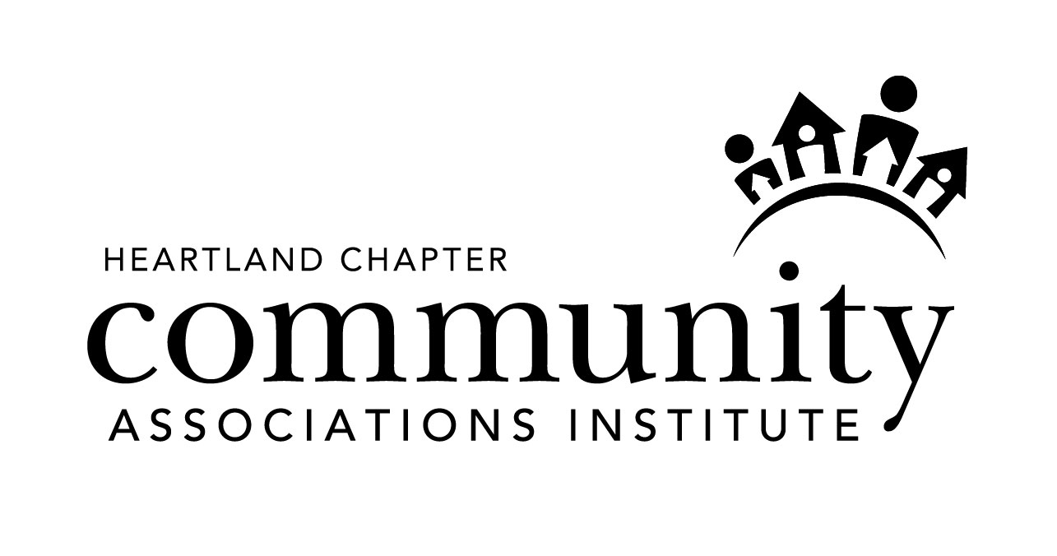
Community Associations Institute
Heartland Chapter
P.O. Box 953
Bridgeton, MO 63044
(314) 423-8859 ∙ ced@caiheartland.com

BOARD OF DIRECTORS

2024 Nomination Information Form
(Please Print)

Name: ___________________________________________________________________________________________

Organization: _____________________________________________________________________________________

Address: _________________________________________________________________________________________

City: ______________________________________ State: ____________ Zip: __________________________

Phone: ______________________________________ E-Mail: ___________________________________________

Type of CAI Membership (Check One):
_______ Community Association Volunteer CAI Member Since: ____________________
_______ Community Association Manager
_______ Business/Service Partners

Please give a short summary of why you are interested in serving on the Chapter Board of Directors. This completed form must be received no later than October 18, 2024 and must have at least three signatures from other members of our local chapter.

__________________________________________________________________________________________________
__________________________________________________________________________________________________
__________________________________________________________________________________________________
__________________________________________________________________________________________________
__________________________________________________________________________________________________

_________________________________________________________ ________________________________
Signature Date

_________________________________________________________ ________________________________
Signature Date

_________________________________________________________ ________________________________
Signature Date

