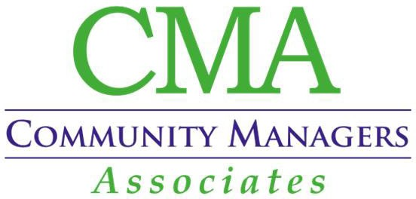
COMMUNITY ASSOCIATION MANAGER

JOB DESCRIPTION

Job Title: Community Association Manager Location: St. Louis, Missouri  Company: Community Managers Associates, Inc. (CMA) Job Type: Full-Time (Exempt)  *Compensation: $60,000 - $65,000 (Full Portfolio) | Benefits:  - 401(k) & 401(k) matching  - Flexible Schedule  - Health Insurance  - Dental Insurance  - Life Insurance  - Paid Time Off  - Tuition Reimbursement

Job Summary:
Community Managers Associates, Inc. is seeking an experienced Community Association Manager to oversee a portfolio of community associations. The ideal candidate will possess exceptional leadership skills, extensive knowledge of community management, and a proven track record of successfully managing multiple associations. This role requires a strategic thinker who can effectively collaborate with board members, residents, and vendors to ensure the highest standards of community living.

Key Responsibilities:
Portfolio Management
- Oversee the management of a diverse portfolio of community associations, ensuring each association
operates efficiently and effectively.
- Develop and implement strategic plans to enhance the overall quality and value of each community within budgetary constraints and in accordance with the management agreement scope of services.
- Conduct regular site visits in accordance with management agreement to assess property conditions and report to Board for further action.

Board Collaboration
- Serve as the primary liaison between the board of directors and the community, facilitating clear and effective communication.
- Provide expert guidance to board members on governance, policy development, and decision-making processes.
- Prepare and present comprehensive management reports and financial statements for board meetings.
- Attend Board and Community Meetings.

Community Member Relations
- Foster positive relationships with community members, addressing concerns and resolving disputes in a timely and professional manner.
- Implement and enforce community rules and regulations to maintain a harmonious living environment.

Financial Management
- Develop and manage annual budgets for each association within the portfolio.
- Oversee the collection of assessments and ensure accurate financial records are maintained.
- Coordinate with accounting team to prepare monthly financial reports and annual audits.

Vendor Management
- Obtain and present vendor bids and proposals for Board consideration.
- Oversee recurring services and maintenance/repair projects, ensuring timely completion and adherence to standards.
- Evaluate vendor performance regularly and make recommendations for improvements or changes.

Compliance and Risk Management
- Ensure all associations comply with local, state, and federal regulations, as well as governing documents.
- Develop and implement risk management strategies to safeguard community assets.
- Stay informed of industry trends and best practices to continuously improve management processes.

Quali�ications

Education and Experience
- Bachelor’s degree in Business Administration, Real Estate, or related field preferred.
- Minimum of 3-5 years of experience in community association management.
- Certified Manager of Community Associations (CMCA) designation preferred.

Skills and Abilities
- Strong leadership and team management skills.
- Excellent communication and interpersonal skills.
- Proficient in financial management and budgeting.
- Ability to multitask and manage multiple priorities effectively.
- Detail-oriented with strong organizational skills.
- Proficient in Microsoft Office Suite and property management software. Vantaca experience preferred.

This job description outlines the responsibilities and qualifications expected of a Community Association Manager at Community Managers Associates, Inc. Adjustments may be made based on the specific needs of the company and the communities managed.

How to Apply:
Interested candidates should submit their resume and cover letter detailing their relevant experience and qualifications to engage@cmamgrs.com. Please include "Community Association Manager Application" in the subject line.

*Commensurate with Total Portfolio Value

